**502571-3 2nd Trimester 2022/2023 HW#2**

# Topics: KNN Sections: 2233 & 3827

# Due Date: Thursday 26 January 2023 – 11:59 pm

# __________________________________________________________

Based on the training set studied in chapter 4 (cf., slide#7)

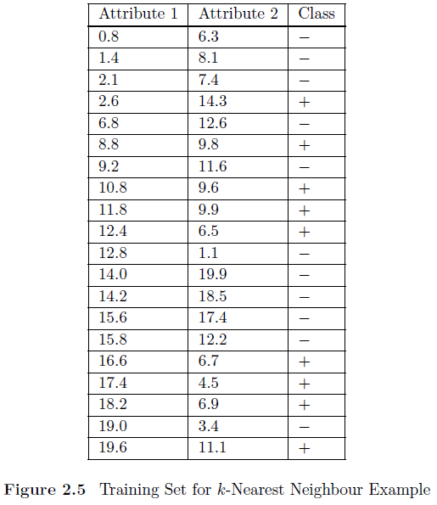

1. Using 5NN algorithm and the Euclidean distance measure, determine the class of the following unseen instance with first and second attributes 9.1 and 11.0, respectively.
2. Answer the first question using the Manhattan distance instead of the Euclidean distance.
3. **Euclidean Distance**

(11-6.3)2 9.538

(11-8.1)2 8.228

(11-7.4)2 = 7.871

(11-14.3)2 = 7.289

(11-12.6)2 = 2.801

(11-9.8)2 = 1.236

(11-11.6)2 = 0.608

(11-9.6)2 = 2.202

(11-9.9)2 = 2.915

(11-6.5)2 = 5.580

(11-1.1)2 = 10.568

(11-19.9)2 = 10.159

(11-18.5)2 = 9.069

(11-17.4)2 = 9.121

(11-12.2)2 = 6.806

(11-6.7)2 = 8.645

(11-4.5)2 = 10.542

(11-6.9)2 = 9.9809

(11-3.4)2 = 12.480

(11-11.1)2 = 10.500

The least five numbers of all numbers

(11-12.6)2 = 2.801 (-)

(11-9.8)2 = 1.236 (+)

(11-11.6)2 = 0.608 (-)

(11-9.6)2 = 2.202 (+)

(11-9.9)2 = 2.915 (+)

Plus is the must, so unseen class is plus (+)

1. **Manhattan** **Distance**

(11- 6.3) =13

(11-8.1) 10.6

(11-7.4)= 10.6

(11-14.3) = 3.2

(11-12.6) = 0.7

(11-9.8) = 1.5

(11-11.6) = 0.7

(11-9.6) = 0.3

(11-9.9) = 1.6

(11-6.5) = 1.2

(11-1.1) = 6.2

(11-19.9) = 13.8

(11-18.5) = 12.6

(11-17.4) = 12.9

(11-12.2) = 7.9

(11-6.7) = 3.2

(11-4.5) = 1.8

(11-6.9) = 5

(11-3.4) = 2.3

(11-11.1) = 10.6

The least five numbers of all numbers

(11-12.6) = 0.7 (-)

(11-9.8) = 1.5 (+)

(11-11.6) = 0.7 (-)

(11-9.6) = 0.3 (+)

(11-9.9) = 1.6 (+)

Plus is the must, so unseen class is plus (+)